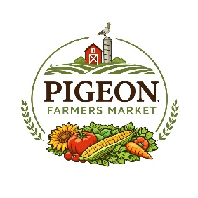

Pigeon Farmers Market Rules
Presented by the Pigeon Chamber of Commerce
Thank you for being part of the Pigeon Farmers Market. Our goal is to create a welcoming, family-friendly, and community-focused market for vendors and shoppers alike.
Please review the following rules carefully.

Market Information
Market Season: Fridays, May 8, 2026 through October 9, 2026
Market Hours: 9:00 a.m. to 3:00 p.m.
Market Manager: Amanda Scott
Phone: 989-941-7989

Market Hours
- Vendors may begin setup at 7:30 a.m.
- All vendors must be fully set up by 8:45 a.m.
- Vendors are expected to remain for the full duration of the market unless approved otherwise by management.
Vendor Spaces
- Vendor spaces are assigned by market management.
- Please remain within your assigned space.
- Vendors must provide their own tents, tables, chairs, and display materials.
- All tents must be properly weighted for safety.

Attendance
- Please notify market management if you cannot attend.
- Repeated no-shows or late arrivals may result in loss of vendor privileges or future placement.
Approved Products
Approved vendors may include:
- Farmers & growers
- Produce vendors
- Bakers
- Honey & maple syrup vendors
- Meat vendors
- Handmade artisans & crafters
- Cottage food vendors
- Flower & plant vendors
- Small businesses
- MLM/direct sales vendors
All products must be approved by market management.
Food Vendors
- Vendors must follow all local and state health department regulations.
- Required licenses and permits must be available upon request.
- Vendors are responsible for safe food handling practices.
Conduct & Professionalism
All vendors are expected to maintain a respectful and professional environment.
The following will not be tolerated:
- Harassment or aggressive behavior
- Excessive profanity
- Negative or defamatory remarks about the market or other vendors
- Attempting to recruit or “poach” vendors during market hours
- Creating conflict or disruption within the market
The Pigeon Farmers Market reserves the right to remove vendors who violate these expectations.

Clean Up
- Vendors are responsible for keeping their spaces clean.
- All trash must be removed at the end of the market day.

Weather Policy
The market operates rain or shine unless conditions are deemed unsafe by market management.
Liability
The Pigeon Chamber of Commerce and Pigeon Farmers Market are not responsible for lost, stolen, or damaged items, weather damage, injuries, or incidents related to vendor products.
Market Rights
The Pigeon Farmers Market reserves the right to:
- Approve or deny vendors
- Reassign vendor spaces
- Limit duplicate vendors
- Remove vendors who violate market rules
Thank you for helping us create a fun, welcoming, and successful community market in Pigeon, Michigan.

